INSTRUKCIJE ZA AUTORE (Style: Times New Roman, 14pt, Bold)

INSTRUCTIONS FOR AUTHORS (Style: Times New Roman, 14pt, Bold)

Name Surname 1, Name Surname 2, Name Surname X (Author's name, Co-author's name - Style: Times New Roman, 11pt, Bold)  Authors’Institution (Style: Times New Roman, 11pt)  Ključne riječi:  abecedni popis ključnih riječi na bosanskom, hrvatskom ili srpskom jeziku (Style: Times New Roman, 10pt)  Keywords:  Alphabetic list of keywords in English (Style: Times New Roman, 10pt)  Paper received:  xx.xx.xxxx.  Paper accepted:  xx.xx.xxxx. |  | Kategorizacija članka (Style: Times New Roman, 10pt, Bold, Italic)  REZIME (Style: Times New Roman, 10pt, Bold)  Naslov rada (do 15 riječi). Puna imena i prezimena autora (bez navođenja zvanja i akademskih titula). Rezime rada (do 150 riječi). Rezime treba što vjernije odražavati sadržaj rada. U njemu se navode upotrebljene metode i ističu ostvareni rezultati kao i doprinos rada. Naslov, rezime rada i ključne riječi autori sa ex-YU prostora pišu i na bosanskom, hrvatskom ili sprskom jeziku. Ključne riječi u pravilu su iz naslova rada, a samo eventualno iz sažetka rada. Ovaj dio rada se ne lektoriše i autori su odgovorni za njegovu jezičnu i gramatičku ispravnost. Nakon završetka recenzentskog postupka autori mogu biti zamoljeni da naprave određene popravke ili dopune svoj rad. (Style: Times New Roman, 10pt, Italic)
Categorization of paper (Style: Times New Roman, 10pt, Bold, Italic)
SUMMARY (Style: Times New Roman, 10pt, Bold)
Title of the paper (up to 15 words). The full list of authors (without specifying grades and ranks). Summary (up to 150 words). Summary should be as faithfully reflect the content of the paper. It outlines the methods used and highlight the results achieved as well as the contribution of the paper. Title, summary of paper and keywords, authors from ex-Yugoslavia area, write to the Bosnian, Croatian or Serbian languages. Keywords are generally from the title of paper, and just possibly from the summary. This part of the paper is not proofread and authors are responsible for the linguistic and grammatical correctness. After completion of the review process, authors may be asked to make certain repairs or additions to their paper. (Style: Times New Roman, 10pt, Italic)

- INTRODUCTION
(Style: Times New Roman, 11pt, Bold)
Upon its acceptance the article is categorized as follows: original scientific paper, preliminary notes, subject review, professional paper and conference paper.
Original scientific papers should report original theoretical or practical research results. The given data must be sufficient in order to enable the experiment to be repeated with all effects described by the author, measurement results or theoretical calculations.
Preliminary notes present one or more new scientific results but without details that allow the reported data to be checked. The papers of this category inform about experimental research, small research projects or progress reports that are of interest.
Subject reviews cover the state of art and tendencies in the development of the specific theory, technology and application with given remarks by the author. Such a paper ends with a list of reference literature with all the necessary items in the related field.
Professional papers report on the original design of an instrument, device or equipment not necessarily resulting from the original research. The paper contributes to the application of well-known scientific results and to their adaptation for practical use.
Papers presented at scientific conferences can also be published in the journal upon the agreement of the conference organizer and the author. (Style: Times New Roman, 11pt, Normal)
Papers to be published in the journal Tehnički vjesnik/Technical Gazette, should be written in English. The metrology and terminology used in the paper have to meet legal regulations, standards and International System of Units (SI)

  - Subtitle 1 (Writing Instructions)
(Style: Times New Roman, 11pt, Bold)
The text of the paper is arranged in sections and when necessary into subsections. Sections are marked with one Arabic numeral and subsections with two Arabic numerals, e.g. 1.1., 1.2., 1.3., ... When a subsection is arranged in smaller parts, each of them is marked with three Arabic numerals, e.g. 1.1.1., 1.1.2., ... Further divisions are not allowed.
The text has to be organized in the following order:
Title of the paper (up to 15 words). Papers should be headed by a concise but informative title that clearly reflects the subject of the paper.
Authors' full names (without grades and ranks).
Summary-Abstract (up to 150 words) should present a brief and factual account of content and conclusions of the paper, and an indication of the relevance of the new material presented.
Title and abstract in Bosnian/Croatian/Serbian (BCS). Only for authors from ex-Yugoslavian area. Alphabetic list of keywords in English and in (BCS). Keywords normally originate from the title and from the abstract.
Introduction should state the reason for the work, with brief reference to previous work on the subject. It informs about the applied method and its advantages.
Central part of the paper may be arranged in sections. Complete mathematical procedures for formula derivations should be avoided. The necessary mathematical descriptions may be given in an appendix. Authors are advised to use examples to illustrate the experimental procedure, applications or algorithms. In general all the theoretical statements have to be experimentally verified.
In Conclusions all the results are stated, and all the advantages of the used method are pointed out. The limitations of the method should be clearly described as well as the application areas.
List of references should be brought together at the end of the article and numbered in square brackets in order of their appearance in the text followed by other literature.
Coressponding authors' full names followed by the name and address of the institution in which the work was carried on.
A List of used symbols and theirs SI units is optional after list of references.
    - Subtitle 2 (Preparation of Manuscript)
(Style: Times New Roman, 11pt, Bold)
The paper should be written using Latin characters. Greek letters may be used for symbols. The volume of the article is limited to 10 pages (A4 format). That includes blanks and equivalent number of characters covered by figures and tables. Number of pages must be even.
The text should be sent to the Editorial Board using e-mail. For the text preparing may be used only MS Word for Windows respectively *.doc, *.docx (Word Document) or *.rtf (Rich Text Format) format of records. The text has to be prepared in accordance with this template.
The Editorial Board may exceptionally request the CD-ROM with recorded articles and figures and tables. In that case the figures (drawings, diagrams and photographs) should be submitted stored on the CD-ROM in JPG/JPEG, PNG, TIF (TIFF Bitmap) or BMP (Windows Bitmap) format, min. resolution of 300 dpi. Each figure is labelled the same as it is in the paper and recorded format (e.g. fig-1.JPG). If figures inserted into text they must be also with min. resolution of 300 dpi.
Latin or Greek characters in italics are used for physical symbols and normal characters for measuring units and numerical values. Text in figures is also written with normal letters. Character size is to be chosen on the basis of the following criteria: after expected figure size reduction a capital Latin character should be about 2 mm high (no less than 6pt).
All figures in the Journal will be printed in black and white technique.
Coloured figures will be seen only in the PDF format on the Web address http://www.mf.unze.ba/index.php?option=com_content&view=article&id=118&Itemid=107
Tables are created with the word processing program. Each table is positioned in the desired place in the text. In the case of decimal numbers use comas (e.g. 0,253); use a small gap separating the thousands (e.g. 25.000, but not in the case of 1500).
The texts under figures and table titles are in English language and in BCS for authors from ex-YU area.
Section titles and titles of subsections are typed in small letters only in English language. Equations are numbered with Arabic numerals in parenthesis at the right margin of the text. In the text an equation is referenced by its number in parenthesis like "... from Eq. (3) follows ...".
Create equations with MS Word Equation Editor (some examples are given below).

(1)

(2)

(3)
(Notice: If you convert and save your document as a MS Word 2010 file and then add equations to it, you will not be able to use previous versions of MS Word to change any of the new equations.).
Figures and tables are numbered with Arabic numerals (1 ÷ n). In the text in figure or table is referenced by its number (e.g. in Fig. 1, in Tab. 1, etc.).

Slika 1. Tekst unutar formula (samo za autore sa ex-YU prostora)
Figure 1 The texts under figures
(Style: Times New Roman, 11pt, Italic)

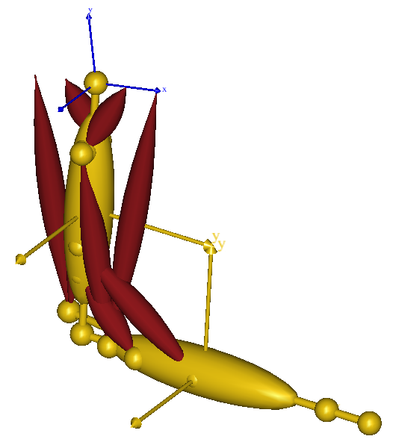

Figure 2. Simplified musculoskeletal model of an arm
(Style: Times New Roman, 11pt, Italic)

When reference to literature is made the publication number from the list of references in square brackets is used like "... in [7] the authors showed ...". In the list of references literature is cited in accordance with examples in Section.

2 COPYRIGHT TRANSFER AGREEMENT

Copyright assignment. The author hereby assigns to the journal "Mašinstvo" the copyright in the above article (for U. S. government employees: to the extent transferable), throughout the world, in any form, in any language, for the full term of copyright, effective upon acceptance for publication.
Author's warranties. The author warrants that the article is original, written by stated author/s, has not been published before and it will not be submitted anywhere else for publication prior to acceptance/rejection by "Mašinstvo", contains no unlawful statements, does not infringe the rights of others, and that any necessary written permissions to quote from other sources have been obtained by the author/s.
Rights of authors. Authors retain the following rights:
- all proprietary rights relating to the article, other than copyright, such as patent rights,
- the right to use the substance of the article in future own works, including lectures and books,
- the right to reproduce this article for own purposes, provided the copies are not offered for sale.

Co-authorship. If the article was prepared jointly with other authors, the signatory of this form warrants that he/she has been authorized by all co-authors to sign this agreement on their behalf, and agrees to inform his/her co-authors of the terms of this agreement.

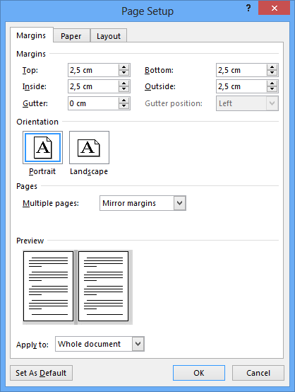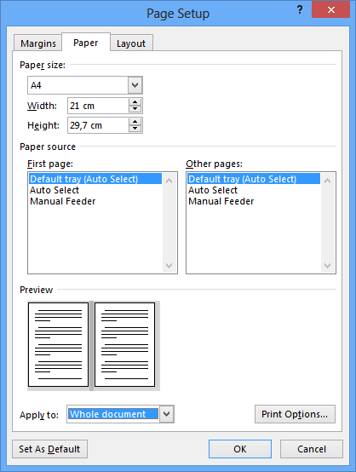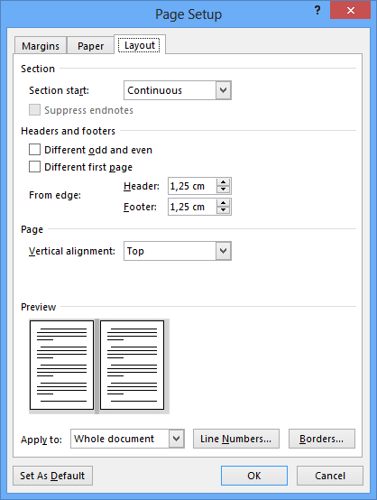

Figure 3. Page setup
(Style: Times New Roman, 11pt, Italic)

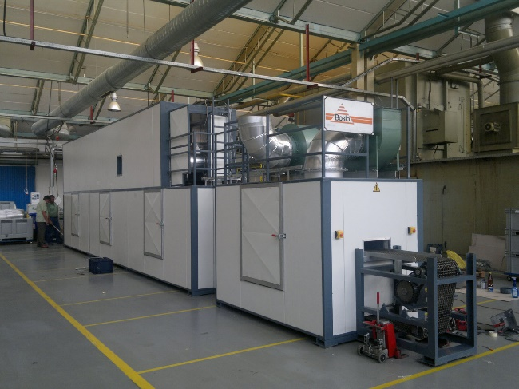
Figure X. Photography resolution of 300 dpi (min)
(Style: Times New Roman, 11pt, Italic)

3. PUBLICATION ETHICS AND PUBLICATION MALPRACTICE STATEMENT
The publication of an article in a peer reviewed journal is an essential model for our journal "Mašinstvo".
It is necessary to agree upon standards of expected ethical behaviour for all parties involved in the act of publishing: the author, the journal editor, the peer reviewer and the publisher.
Publication decisions. The editor of the "Mašinstvo" is responsible for deciding which of the articles submitted to the Journal should be published.
The editor may be guided by the policies of the Journal's editorial board and constrained by such legal requirements as shall then be in force regarding libel, copyright infringement and plagiarism. The editor may confer with other editors or reviewers in making this decision.
Fair play. An editor at any time evaluate manuscripts for their intellectual content without regard to race, gender, sexual orientation, religious belief, ethnic origin, citizenship, or political philosophy of the authors.
Confidentiality. The editor and any editorial staff must not disclose any information about a submitted manuscript to anyone other than the corresponding author, reviewers, potential reviewers, other editorial advisers, and the publisher, as appropriate.
Disclosure and conflicts of interest. Unpublished materials disclosed in a submitted manuscript must not be used in an editor's own research without the express written consent of the author.
Contribution to editorial decisions. Peer review assists the editor in making editorial decisions and through the editorial communications with the author may also assist the author in improving the paper.
Acknowledgement of sources. Reviewers should identify relevant published work that has not been cited by the authors. Any statement that an observation, derivation, or argument had been previously reported should be accompanied by the relevant citation. A reviewer should also call to the editor's attention any substantial similarity or overlap between the manuscript under consideration and any other published paper of which they have personal knowledge.

Table 1. Table titles (Style: Times New Roman, 11pt, Normal)
Engineering  stress  σ_{e} / MPa | Engineering  plastic strain  ε_{e,pl} / % | True stress  σ_{t} / MPa | True plastic  strain  ε_{t,pl} / %
250,0 | 0,00 | 250,8 | 0,00
250,0 | 0,21 | 250,8 | 0,21
285,7 | 1,35 | 290,0 | 1,34
322,7 | 2,13 | 330,1 | 2,10
358,4 | 3,06 | 370,0 | 3,00
393,1 | 4,35 | 411,0 | 4,24
423,6 | 6,05 | 450,1 | 5,85
449,7 | 8,76 | 490,1 | 8,36
457,0 | 15,79 | 530,1 | 14,59
467,9 | 21,58 | 570,0 | 19,45
475,0 | 29,77 | 617,5 | 25,94
(Style in table: Times New Roman, 11pt, Normal)

X. CONCLUSION
Paper manuscripts, prepared in accordance with these Instructions for Authors, are to be submitted to the Editorial Board of the "Mašinstvo" journal. Manuscripts and the CD-ROM are not returned to authors. When being prepared for printing the text may undergo small alternations by the Editorial Board. Papers not prepared in accordance with these Instructions shall be returned to the first author. When there are several authors the first author is to be contacted. The Editorial Board shall accept the statements made by the first author.
The author warrants that the article is original, written by stated author/s, has not been published before and it will not be submitted anywhere else for publication prior to acceptance/rejection by "Mašinstvo", contains no unlawful statements, does not infringe the rights of others, and that any necessary written permissions to quote from other sources have been obtained by the author/s.

XX. REFERENCES
(Style: Times New Roman, 11pt, Normal)
- P.E. Nikravesh, Computer-Aided Analysis of Mechanical Systems, Prantice Hall Inc.,Englewood Cliff,NJ,1988.
- Gordon Robertson, Graham Caldwell, Joseph Hamill, Gary Kamen, Saunders Whittlesey: Research Methods in Biomechanics, Human Kinetics; 2nd edition, 2014.
- Imai, M.: KAIZEN: the key to Japan’s competitive success, Editorial CECSA, Mexico. In Spanish, 1996.
- Nemoto, M.: Total quality control for management. Strategies and techniques from Toyota and Toyoda Gosei, Prentice-Hall, Englewood Cliffs, NJ, 1987.
- Cheser, R.: The effect of Japanese KAIZEN on employee motivation in US manufacturing, Int J Org Anal 6(3):197–217, 1998.
- Aoki, K.: Transferring Japanese KAIZEN activities to overseas plants in China, Int J Oper Prod Manag 28(6):518–539, 2008.
- Tanner, C.; Roncarti, J.: KAIZEN leads to breakthroughs in responsiveness and the Shingo prize at Critikon, Natl Prod Rev 13(4):517–531, 1994.
- Rink, J.: Lean can save American manufacturing. Reliable plant. http://www.reliableplant.com/Read/330/lean-manufacturing-save. Accessed at 14 April 2014.
- SolidWorks, http://www.solidworks.com (12.5.2015)

Coresponding author:
Name and surname
Institution
Email: xxxxxx@xx.xxxxx.xx
Phone: +xxx xx xxxxxx
(Style: Times New Roman, 11pt, Bold)

